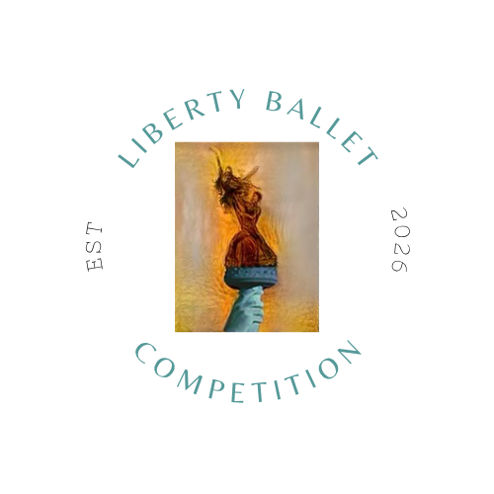
WAIVER
Liberty Ballet Competition and the venue hosting the event are not responsible for any personal injury or property loss that is suffered by anyone attending or participating in the competition. Liberty Ballet Competition reserves the rights to change, delete, or add to any rules, regulations, or policies at any time deemed necessary. Liberty Ballet Competition reserves the right to cancel the event due to lack of registration, weather, or other unforeseen circumstance. If an extenuating weather or unforeseen circumstance arises and Liberty Ballet Competition cancels an event and it is not rescheduled, refunds or credits for the following year will be provided. If the event is rescheduled, no refunds will be given. Should an extenuating circumstance arise, please check the website and/or your email address that you registered under for any event updates.
By signing this Release Agreement, all registered competitors grant permission to Liberty Ballet Competition and its representatives to publish their photographs/videos on local or national television, promotional videos, marketing materials, the internet, or any other visual media, as deemed fit by Liberty Ballet Competition in an effort to promote the competition. In addition, all representatives, staff, and faculty are released and held harmless from any and all claims for damages or injuries sustained while participating or attending any activity related to any and all Liberty Ballet Competition events. All photographs/videos taken by Liberty Ballet Competition and any independent representative commissioned by Liberty Ballet Competition become the property of Liberty Ballet Competition.

School/ Studio Name, Teacher Signature

Date

Primary Guardian Signature (Youth - Pre-Professional Category Aged Competitors) Competitor’s Signature (If over 18)

Date

